**Project Proposal on**

**Bus Ticket Management System**

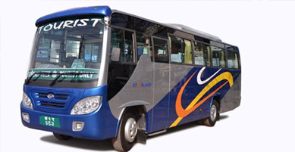

**Prakash Bohara**

**00175880**

**Computing Project**

Level 5 Diploma in Computing

Softwarica College of IT & E-Commerce

Kathmandu, Nepal.

**Table of Contents**

**Chapter-1:- Overview.** 3

**1.1:- Introduction to the system.** 3

**1.2:- Background to the system.** 3

**1.2.1:- Problem statement:-** 3

**1.3:- Justification to the project.** 3

**1.4:- Overview of the purposed system.** 4

**Chapter-2:- Project Scope.** 4

**2.1:- Aims of your project.** 4

**2.2:- Objectives of your project.** 4

**2.3:- Features to be included in your project.** 5

**Chapter-3:- Development Methodology.** 6

**3.1:- Methodology to be used.** 6

7

**3.2:- Design Pattern.** 7

**3.3:- System Architecture.** 8

**Chapter-4:- Scheduling.** 10

**4.1:- WORK BREAKDOWN STRUCTURE (WBS).** 10

**4.2:- MILESTONES.** 12

**4.3:- Gantt chart.** 14

**Chapter-5: Risk Management.** 16

**Chapter-6:- Configuration Management.** 18

**Chapter-7:- Conclusion.** 19

**References and Bibliography:-** 20

# **Chapter-1:- Overview.**

## **1.1:- Introduction to the system.**

Every organization will need to have a record management system to store all the information about them in correct order, high security and at lower cost. Bus ticket management system is a desktop based application that manage the bus tickets and store the data about the passengers, bus owner, and route of the bus. This Bus Ticket Management System is for the Mahakali Bus Yatayat. It help to reduce the paper work. The purpose of this project is to replace the manual paper based system to the computerized or automated system. It will help to make increased level of efficiency and user friendly environment.

## **1.2:- Background to the system.**

### **1.2.1:- Problem statement:-**

Currently, the type of system being used at the counter of Mahakali Bus Yatayat is an internal system which is manually and paper based system that is used in selling the bus tickets. The problems facing the company are that the staff at counter has to make record of the passenger, Bus schedule, and bus ticket manually into paper which makes them working uncomfortable and time consuming process and there is problem of data redundancy and data duplication.

To overcome the problem of the data redundancy and data duplication and many more we are developing new automated computerized system that will increase the productivity and make the system secure and robustness.

## **1.3:- Justification to the project.**

The Bus ticket management system will overcome with the all the flaws at the counter of the Mahakali Bus Yatayat. The manual paper work is replaced by new computerized system. This software can be used in every counter of Mahakali Yatayat that are all over the country. This software will help to make work more comfortably. It will make the passenger easy to find tickets. It will helps to increase increased level of communication between passenger and Bus Company. This software will reduce the time taken through manual system in order to maintain all records. That’s why this project is good to do and help a lot in sector of Bus Management.

## **1.4:- Overview of the purposed system.**

The all work of proposed Bus Ticket Management System will be digitalized and done via computers. All the data of the passenger, bus schedule, bus ticket will be saved in servers. Backup should be made of all the important data into cloud like iCloud and Google Drive.

The Bus Ticket Management System is developed for all counters of Mahakali Bus Yatayat that will replace their existing manual and paper based system. This software will manage information of passenger, bus schedule, and bus ticket and route of the bus. This software will increase the productivity, efficiency and reduce the time and resources.

# **Chapter-2:- Project Scope.**

## **2.1:- Aims of your project.**

As we know that every project have their own aim for the projects. This project also have the many aims and they are listed below:-

1. The aim of the system is to design desktop based application that will store the data of the passengers, bus schedule, and bus ticket.
2. The aim of the system is to design an application that will be user friendly, time efficient and at low budget.

## **2.2:- Objectives of your project.**

Objectives are the steps taken to fulfill the aim of an organization, person or system. The aim is achieved within time a time frame and with available resources. The objectives of the Bus Ticket Management system are mentioned below:-

* Its helps to track the information of all passenger, drivers and bus destination.
* It has to provide better HCI for the users.
* Logical and physical diagram are described to manage the database and programming.
* Test of the code must be done to decrease the bugs that can occurs in future.
* Designing the different types of modeling like data flow diagram, use case, activity diagram etc.
* Documentation of all designs, modeling, and development information.

## **2.3:- Features to be included in your project.**

🡪Staff login and registration

🡪 Passenger registration/information

🡪 Bus registration/information

🡪Bus source, route and destination

🡪Passenger source and destination

🡪CRUD operation for staff, bus and passenger.

🡪Ticket rate

# **Chapter-3:- Development Methodology.**

## **3.1:- Methodology to be used.**

I will be the one and only person for the development of the Bus Ticket Management System. In this project I will have to do analysis, design, coding, testing and maintenance without team mates. There are many methodologies used in the development of the software and examples of the methodologies are listed below:

* Waterfall Model
* V-shape Model
* Agile methodology

In this project, I will use waterfall methodology because this methodology is easy to use and understand. As our project is small so waterfall model is suitable for Bus Ticket Management System.

Some Advantages and disadvantages of waterfall methodology are listed below:-

**Advantage**

1. It is easy to use and understand
2. Easy to manage due to rigidity of the model
3. Work well for smaller project where requirement are well known.

**Disadvantage**

1. There is no possible to return a previous stage, if any phases goes wrong there is more complicated to solve it.
2. High amount of risk and uncertainty.
3. User requirement cannot be gather properly because it is not an iterative process since it flow a model sequentially.

Given diagram, illustrate the each step of waterfall model:

Requirement Analysis

System Design

Implementation

Testing

## 

Maintenance

Fig1:- Phases of Waterfall Model.

## **3.2:- Design Pattern.**

There are many design pattern like factory design pattern, flyweight, and façade design pattern, MVC design pattern. But among them I will use MVC design pattern in Bus Ticket Management System. MVC stands for Model View and Controller. The design patterns allow developers to communicate using well-known, well understood names for software interactions. Design pattern is use for speed up the development process by providing tested, proven development paradigms.

The MVC Design Pattern consist of 3 parts and they are listed below:-

* **Model: -** It is a data used by the application or program that might be database, file, or a simple object, such as an icon.
* **View: -** It is the medium for displaying objects within an application or program. It includes everything that the user can see. For example displaying a window or buttons or text within a window.
* **Controller: -** It is used to updates both models and views. It accepts input and performs the corresponding update.

**Advantages of MVC Design Pattern:-**

* It helps to develop faster web and desktop application development process.
* It offers multiple views.
* Modification does not affect the entire model.
* It support for asynchronous technique.

The figure that will describe MVC Design Pattern is shown below:-

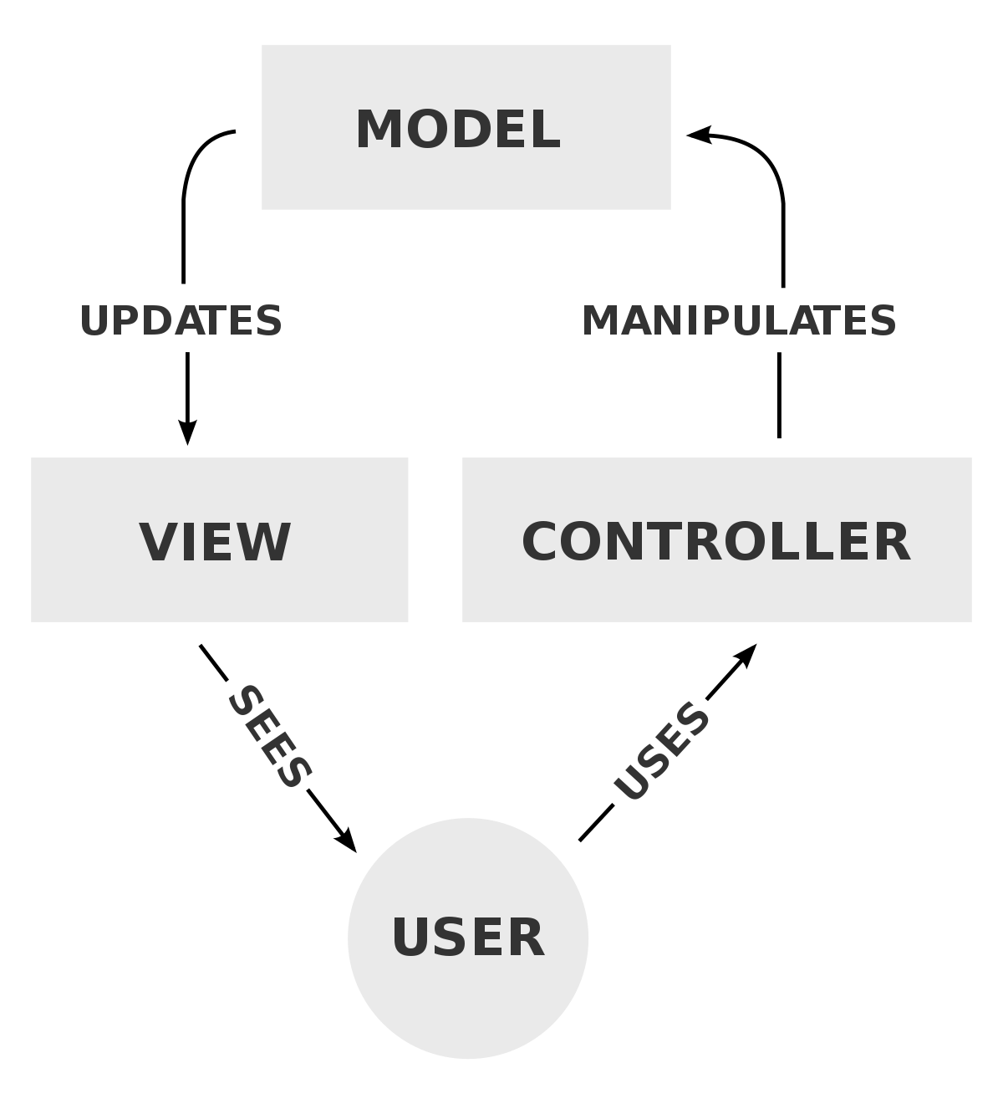

Fig2:- MVC Design Pattern.

## **3.3:- System Architecture.**

The system architecture that I will using in Bus Ticket Management System is 3-tier architecture. A 3-tier architecture is a type of software architecture which is composed of three “tiers” or “layers” of logical computing. They are often used in applications as specific type of client- server system.

The three tier of 3-tier architecture are descried briefly below:-

* **Presentation Tier: -** The presentation tier is the front end layer in the 3-tier system and consists of the user interface. This tier communicates with other tiers by sending results to the database.
* **Application Tier: -** The application tier contains the functional business logic which drives an applications more capabilities. It controls application functionality by performing detailed processing.
* **Data Tier: -** The data tier comprises of database/data storage system and data access layer. Examples are MySQL, Oracle, and Microsoft SQL Server etc. Data in this tier is kept independent of application servers or business logic.

The figure of 3-tier architecture is shown in below:-

**Client**

**Application Server**

**Database Server**

Fig-3:- 3-tier Architecture

# **Chapter-4:- Scheduling.**

## **4.1:- WORK BREAKDOWN STRUCTURE (WBS).**

Work Breakdown Structure is the technology used for breakdown of a complete project into smaller components. It helps to complete project on time and easily. The pictorial representation of WBS helps to provide knowledge about possible outcome from the project plan and changes that might occurs in the project plan.

There are the many purpose of using WBS in any projects. The major purpose of using WBS in Bus Ticket Management System are as below:-

* It helps to decrease the complicated activities of the project.
* It helps to track the progression and completion percentage of project according to the scheduling.
* It helps to break down the task into manageable chunks.

The Work Breakdown Structure (WBS) of Bus Ticket Management System is shown below:-

Fig-4:- WBS Diagram.

## **4.2:- MILESTONES.**

A project milestone is a management tool that is used to delineate a point in a project schedule. It is a way to observe, measure and monitor the progress and/or performance of a project. Milestones in general exist as intermediate stages that must be fulfilled before reaching a final goal or objective.  They can also serve as proof for explaining and reporting the status of a project. Milestones can also be used to maintain accountability and motivate staff.

|  |  |  |
| --- | --- | --- |
| **S.N** | **Milestone** | **Date** |
| **1**  1.1  1.2  1.3 | **Project Management**  Scoping  Planning  Proposal Submission | **6/15/19 8:00 AM to 6/30/19 5:00 PM**  6/15/19 8:00 AM to 6/20/19 5:00PM  6/21/19 8:00 AM to 6/25/19 5:00PM  6/26/19 8:00 AM to 6/30/19 5:00PM |
| **2**  2.1  2.2  2.3 | **Analysis**  Requirement Gathering  Use Cases  Architecture | **7/1/19 8:00 AM to 7/30/19 5:00PM**  7/1/19 8:00 AM to 7/12/19 5:00PM  7/13/19 8:00 AM to 7/20/19 5:00PM  7/21/19 8:00 AM to 7/30/19 5:00PM |
| **3**  3.1  3.2  3.3  3.4 | **Design**  Structural Modelling  Behavioral Modelling  User Interface Design  Database Design | **8/1/19 8:00 AM to 8/20/19 5:00PM**  8/1/19 8:00 AM to 8/5/19 5:00PM  8/6/19 8:00 AM to 8/12/19 5:00PM  8/13/19 8:00 AM to 8/17/19 5:00PM  8/18/19 8:00 AM to 8/20/19 5:00PM |
| **4**  4.1 | **Implementation**  Coding | **8/21/19 8:00 AM to 8/30/19 5:00PM**  8/21/19 8:00 AM to 8/30/19 5:00PM |
| **5**  5.1  5.2 | **Testing**  Unit Testing  Integration Testing | **9/1/19 8:00 AM to 9/9/19 5:00PM**  9/1/19 8:00 AM to 9/5/19 5:00 PM  9/6/19 8:00 AM to 9/9/19 5:00 PM |
| **6**  6.1  6.2  6.3 | **Reporting**  User Manual  Final Report  Presentation Materials | **9/10/19 8:00AM to 9/15/19 5:00 PM**  9/10/19 8:00 AM to 9/11/19 5:00 PM  9/12/19 8:00 AM to 9/13/19 5:00 PM  9/14/19 8:00 AM to 9/115/19 5:00 PM |

Table-1: - Time estimation of the project.

In this stage, all the project stages are allocated a period within which it is hoped to be achieved. Allocation milestone helps in a better time management and ultimately deliverance of project on time.

**Description of Milestone:-**

The broad area of works are shown at higher levels where as the exact activities are seen in the lower level break downs of respective work.

* **Project management(15 days)**
* Scoping (5 days)
* Planning(5 days)
* Proposal Submission(5 days)
* **Analysis(30 days)**
* Requirement gathering(12 days)
* Use case diagram(8 days)
* Architecture(10 days)
* **Design(20 days)**
* Structural Model(5 days)
* Behavioural Model(7 days)
* GUI Design(5 Days)
* Database Design(3 days)
* **Implementation(10 days)**
* Coding(10 days)
* **Testing(9 days)**
* Unit testing(5 days)
* Integration testing(4 days)
* **Reporting(6 days)**
* User Manual(2 days)
* Final Report(2 days)
* Presentation Materials (2 days)

## **4.3:- Gantt chart.**

A Gantt chart is a useful graphical tool which shows activities or tasks performed against time. It is also known as visual presentation of a project where the activities are broken down and displayed on a chart which makes it is easy to understand and interpret. This gives an instant overview of a project, its associated task and where there need to finished.

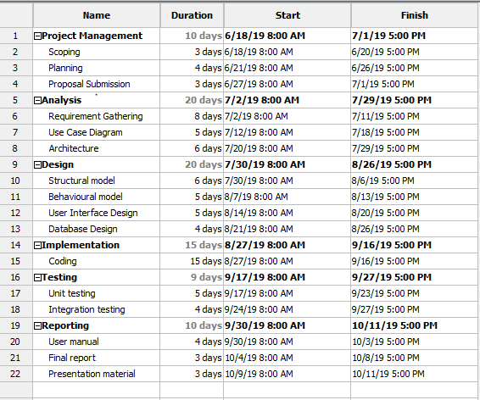

Fig-5:- Project Scheduling

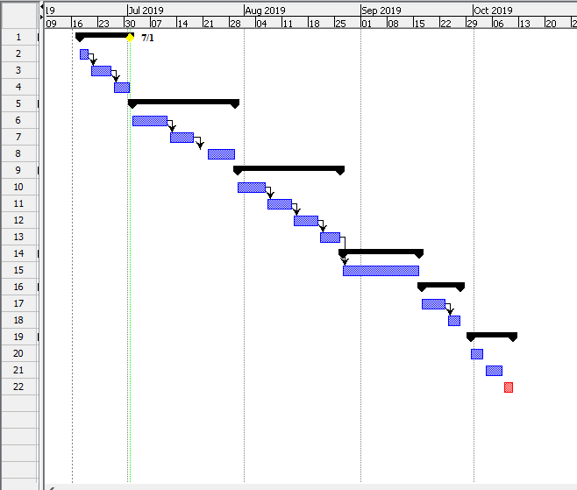

Fig-6:- Gantt chart

# **Chapter-5: Risk Management.**

Risk Management is the process of identifying access and control of the threats. Risk having high impact and greatest probability of occurrence is tackled at first and risk having the lower impact and lowest probability of occurrence are tackled in descending order.

Risk Management involves identification of risks at the projects outset and control of those risks as the project unfolds. There are four steps in Risk Management and they are identify risks, access impact of risk, alleviate critical risk and control risk.

**Impact=Likelihood * Consequence**

|  |  |
| --- | --- |
| Likelihood | Value |
| Low | 1 |
| Medium | 2 |
| High | 3 |

Table 2:- Likelihood

|  |  |
| --- | --- |
| Consequence | Value |
| Very Low | 1 |
| Low | 2 |
| Medium | 3 |
| High | 4 |
| Very High | 5 |

Table 3:- Consequences

The risks that might come while developing Bus Ticket Management System and their likelihood, consequence, impact and action overcome from the risks are presented below in risk management matrix table.

|  |  |  |  |  |  |
| --- | --- | --- | --- | --- | --- |
| R ID | Risk | Likelihood | Consequence | Impact | Action to be performed |
| R101 | Unauthorized Access | 2 | 4 | 8 | Strong password policy and frequent password change should be done. |
| R102 | Hard Disk Failure | 2 | 5 | 10 | Important data should be regularly backup and data should be stored in google drive. |
| R103 | Earthquake | 1 | 5 | 5 | The deadline of submission of project should be extended. |
| R104 | Data Theft | 2 | 5 | 10 | Implementation of digital signature in the area of VIP data. |
| R105 | Cut of the internet connection | 2 | 3 | 6 | Always maintain for the backup secondary internet connection. |
| R106 | Load shedding problem | 2 | 4 | 8 | Make backup of the power supply like innovators. |
| R107 | illness and fever | 1 | 5 | 5 | Maintain proper healthy habits and regular health checkup. |
| R108 | Change of the requirements and update of requirements | 3 | 4 | 12 | Proper use of design pattern and agile development. |

Table-4:- Risk Matrix table.

# **Chapter-6:- Configuration Management.**

Configuration Management is a process for ensuring consistency among physical and logical assets in an operational environment. It helps to improve productivity by increased coordination among the administrators, technicians and software developers. All project artifacts reside into two locations i.e. the Local directory and GitHub directory.

The types of activities in configuration management are change management, release management and version control management.

The purpose of the change management system is to implement the approved changes to the project with minimum amount of disruption.

Release management is the process of managing, planning, scheduling and controlling a software build through different stages and environments including testing and deployment.

Version control is also known as the revision control. I have used GitHub for version control.

The directory is based on major phases of SDLC. Each Phase has a unique folder and all documents, code base and modelling diagram are reside in respective folders.

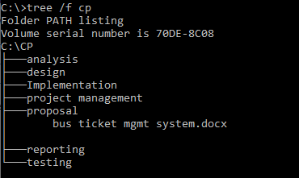

Fig-7:- Directory structure of Project on local Machine.

# **Chapter-7:- Conclusion.**

Bus Ticket Management System is a one type of desktop application that enable to store the information about bus and passenger. It especially make a system easier to handle the all process of ticket selling. It will manage the source, destination and route of bus and passenger and ticket rate with respect to bus.This software will reduce the time taken through manual system in order to maintain all records.

# **References and Bibliography:-**

Andrew, S., 2011. *www.economictimes.indiatimes.com.* [Online]   
Available at: https://economictimes.indiatimes.com/definition/gantt-chart

Carey, M., 2010. *www.interserver.net.* [Online]   
Available at: https://www.interserver.net/tips/kb/mvc-advantages-disadvantages-mvc/

Eon, C., 2006. *www.sourcemaking.com.* [Online]   
Available at: https://sourcemaking.com/design_patterns

Moris, B., 2005. *www.study.com.* [Online]   
Available at: https://study.com/academy/lesson/what-are-milestones-in-project-management-definition-examples.html

Roy, A., 2013. *www.jinfonet.com.* [Online]   
Available at: https://www.jinfonet.com/resources/bi-defined/3-tier-architecture-complete-overview/